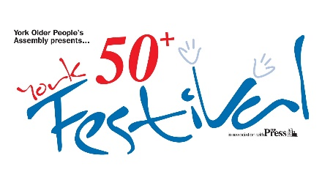 | York Older People’s Assembly  St Sampsons Centre, Church St, York, YO1 8BE  Registered Charity 1101018  yorkolderpeoplesassembly@outlook.com  www.yorkassembly.org.uk
YORK 50+ FESTIVAL 21 Sep - 6 Oct 2024
Business events & advertisements

We are delighted by the continuation of the York 50+ Festival!

The 19th York 50+ Festival will run from Sat. 21 September to Sun. 6 October this year. Now is the time for businesses large and small to start thinking how they can take advantage of this opportunity.

We know the population is getting older, we know that about a third of York's population is over 50 and over 20,000 are retired. During the Festival we are focusing on the positives, celebrating creativity and sharing ways of growing older with gusto. You know your business – what can you contribute and how can you benefit? What kind of networking opportunities can you explore? Who do you want to reach? Are you interested in sponsoring the Festival, or putting an advert in the programme?

Consultants? Makeovers? Special bargains? Events? Fashion shows? The History of…? Taster sessions? Demonstrations? Performers? Tours? Competitions? Vouchers? Volunteers? The ball is in your court.

All offerings and events will go in the Festival Programme available from early September – 4,000 min. copy distribution plus media publicity and website presence for 12 months.

1. If you would like to place an advertisement, please complete the form below.
2. If you would like to hold an event, please complete an Event form, attached or downloadable from our website: www.yorkassembly.org.uk.
Completed forms & fees to be returned to the Festival at the YOPA address by 31 July
To discuss sponsorship or other possibilities, contact the Festival Team at yorkfiftyplus@gmail.com or ring the Festival Co-ordinator on 07920 162034.

YORK 50+ FESTIVAL 2024: Sat. 21 September – Sun. 6 October 2024
Please complete and return by 31 July programme deadline:-
a) Paper copies to YOPA, St Sampson’s Centre, Church Street, York, YO1 8BE with cheque payable to YOPA…. or by BACS to bank account: 77997668 sort code: 309950
b) Email completed form with artwork (jpeg format) attached to yorkfiftyplus@gmail.com.
Contact Name…………………………………………………… Email……………..…………... Phone ………………………... Organising business……………………………………………
Address………………………………………………………………………………………………..

Please select size: ¼ A5 page (6.5x8.5cm, portrait) £50
½ A5 page (13x8.5cm, landscape) £100
full page (13x17cm, portrait) £200

Artwork in high quality jpeg format only please.

